# Overall Advice

* **Check your calculations. Don’t assume yours are right. They can cost you a lot of marks.**
* **Be very specific - ambiguity will not pass:**
  + Rather than larger temperature rise, write ‘double temperature rise’.
  + Rather than ‘one dissociates more, say which one does.
* Avoid abbreviations (eg, ppt or e-) for the SPaG questions.
* Follow the question through (eg, if CO2 was released from a compound earlier than it won’t effervesce if acid is added again).
* Go back at the end and ensure:
  + All equations are balanced (include [H]’s).
  + All carbons have 4 bonds.
* Always write ‘more energy required to overcome’ for the relevant questions.
* Remember the sign for enthalpy change.
* Try and draw a good tangent, get it in range.
* When asked to name groups, you must write the names (not -OH). Note that alcohol and phenol **ARE DIFFERENT** just like a -OH and a -COOH group.
* Careful when converting from molcm-3 to moldm-3, think about which is smaller or bigger.
* When doing hydrolysis questions, work backwards, consider what things had to join together.
* Try and use comparative words like **stronger** and **weaker** throughout (eg, when comparing bonds).
* Be specific in groups, don’t write that benzoic acid is e- withdrawing but rather the -COOH group.
* When listing ions, put charges on them.
* Be specific with what more attraction is to. Eg, more attraction **to water** for enthalpy changes of hydration.
* Make sure equations are balanced by listing elements either side, be careful with subscripts.
* Ensure that everything is counted from the MR of a skeletal formula - including 12C’s.
* Be on the lookout for limiting reagents (eg, under calorimetry.)

# U1 - Development of Practical Skills

## Advice

* Add units to the tables.

## Extra Content

* If you have a greater reactant then you’ll have a smaller % error in mass. If this means greater temperature rise too, smaller % in temperature rise too. Yet, too much can lead to not all of it reacting.

# U2 - Foundations in chemistry

## Advice

* Be sure to remember that a substance that acts as a reducing agent is oxidised.
* Compare the strength of bonds when you deem it’s relevant.
* **Label the 1H bond** when asked to draw it.
* Be specific, it forms more 1H bonds **with water**.
* Remember that you can have a 1H bond drawn with an amine group:

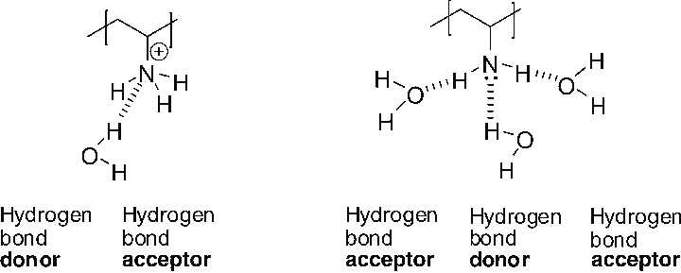

* Remember to consider lone pairs on molecules, NH2- is 104.5 degrees.
* Draw dotted lines in polymerisation.
* When comparing subshells, say which has the higher energy.
* Whenever you mention lone pairs, say **LONE PAIRS REPEL MORE THAN BONDING PAIRS**.

## Extra Content

* When needing to increase the rate of reaction, use test tubes in a water bath.
* The main force in PH3 would be permanent dipole-dipole interactions rather than London Forces as permanent dipole-dipole interactions are stronger.
* There is a drop in ionisation energy going from nitrogen to oxygen as the e-’s begin to pair.
* Remember that 1 dm3 = 1000g so the concentration of water is approx. 56 moldm-3 since 1000 / 18 = 55.5.
* Systematic name for KClO4 is potassium chlorate (VII).
* Less surface area of contact so **WEAKER** London forces.
* Show a substance acts as a catalyst by saying it’s reformed.

# U3 - Periodic table in chemistry

## Advice

* When writing an ionic equation, remember, it’s literally just the most important things reacting.
* Mention when some property is the same across periods/groups (eg, shielding).
* Mention whenever something is **giant** covalent lattice, **giant** metallic lattice, or **simple** molecular.
* When a question says ‘standard’ then ensure every reactant/product is in its standard state, otherwise this is a problem: non-standard conditions can be a reason for experimental values being different from theoretical.
* For enthalpy change of neutralisation, you divide by the number of moles of water produced at the end (may not always be a 1:1 ratio).

## Extra Content

* A bottle of vinegar will contain other acids so, in reality, it’s not good for a titration.
* Ensure you prepare a sufficient amount so you can take a sample and titrate it.
* If the volume used is doubled, the temperature rise would be the same as double the energy is released over the double the volume and thus the enthalpy change is the same as double energy for double moles.
* Percentage yield has no impact on the sustainability of a process - its merely a measure of how successful that particular reaction was.

# U4 - Core organic chemistry

## Advice

* When writing the formulae of aldehydes in a condensed way write CHO and not COH e.g.CH3CH2CHO.
* Always quote ranges for IR questions.
* Remember that everything under mass spectroscopy is an ion so write charges.
* If it says structural isomers then draw structural isomers, not stereoisomers.
* Treat each functional group separately, as long as you know what happens to each then you’ll be fine for large molecules.
* Always mention **REPELLING ELECTRONS** for shapes of molecules.
* You can simply say **‘more likely to form because more stable carbocation intermediate’**.
* You will have CnH2n + 2 for a compound with no rings and only single bonds yet if you have 2 rings then you will have CnH2n - 2. Consider manipulating algebraic formulae carefully.
* There is no need to draw electrophilic substitution with geometry flipping.
* Draw a circle around the correct double bond for stereoisomerism (though there may be multiple C=C’s)

## Extra Content

* Higher electron density so **more susceptible to attack**.
* Use fragment ions to differentiate between isomers.
* A secondary carbocation will have a +ve charge on a 2° carbon.
* You have two regions of an infrared spectrum, the right crazy-looking section is the fingerprint section which you should ignore. The left is the functional group identification region.
* Always add charges on molecular ion peaks - even largest peak.

# U5 - Physical chemistry and transition elements

## Advice

* Use the Gibbs free energy equation to make explanations easier.
* When forming a buffer solution, you may have to account for weak acid and strong base reacting. The concentration of the weak acid will decrease.
* Remember that atomisation is 1 mol formed so if you have ½ I2 → I, you have double the enthalpy change as 2 mols are formed.
* When explaining in terms of KC be sure to mention that **KC must remain constant**. You can mention the KC ratio decreases before being restored if you wish. “Shifts to restore KC”.
* Show a reaction is first order by measuring the half-life.
* Always look for when you may need to x 2 in a Born-Haber cycle.
* You don’t need to know anything about cobalt, don’t even mention it.
* Example of how a KC question should be answered:

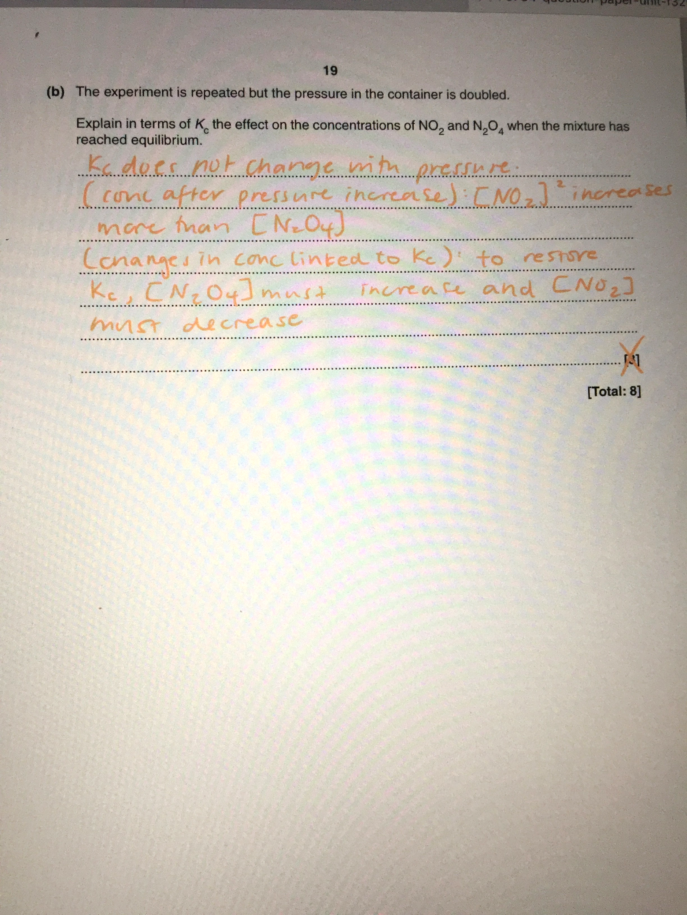

* Oxidising agents for cell potentials go forwards, reducing agents go backwards. Always use the definitions.

## Extra Content

* Structures can bond to themselves to form cyclic structures (eg, -COOH and -NH2 on the same molecule).
* When talking about entropy change, use words like **disorder**.
* There is a leeway in times with half-lifes in 1st order reactions. Only a **major difference** would mean 2nd order.
* You have NH2 in a bidentate ligand (not NH3) from like in C2H8N2 is ethane-1,2-diamine.
* You only have optical isomers for complex ions like this:

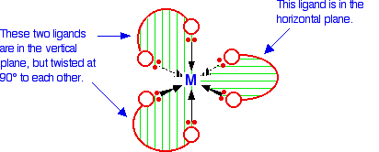

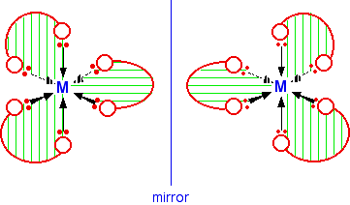

* Buffers work best when pKa = pH ± 1 (like in the ‘magic tang’ question).

# U6 - Organic chemistry and analysis

## Advice

* Look out for all the -NH2’s during acid hydrolysis as they will turn to -NH3+Cl-.
* Rather than saying phenol is more polarising, you can say Cl2 has become polarised too.
* Remember that the 4s empties first!
* Add catalysts to the reagents, like AlBr3 for Br2.
* Phenol is weakly acidic so it doesn’t appear on 13C spectrum.
* LABEL REGIONS ALWAYS. Eg, for 110 - 160 ppm on 13C indicates 4 aromatic environments.
* Remember that NaOH can react with both COOH and -OH phenol group.
* Mention π-bonds.
* Remember you can have a carboxylate salt forming instead of a carboxylic acid. Be on the lookout. Even those attached to benzene.
* Commenting on largest fragment ion useful for NMR too. Be sure to count the number of environments of isomers to ensure it matches.
* Join polymers properly, don't move some group from one end to the other.
* Remember DROPE (delocalised ring of pi electrons).
* Remember that the phenol group reacts with Na+ too.
* If it's polarising then draw the Br-Br being polar, even for cyclic molecules.
* Use CONCENTRATED HCl to convert from nitrobenzene to phenylamine (with Sn too).

### NMR

* Remember that each 1H will show its most unique environment - this is vital.
* Try and refer to all pieces of evidence carefully.
* TMS is used because it’s a standard and to calibrate.
* CDCl3 or CCl4 is used because it doesn’t cause interference or give a peak.
* Add possible parts of molecule to the NMR.
* Ignore the splitting of benzene in 1H NMR, it just makes things a lot more complicated.

## Extra Content

* Draw mirrors images like below:

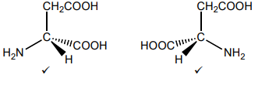

* By similar structures, it doesn't always mean the same chain length, one can be slightly longer but have the same functional group.
* Benzene is unsaturated.
* If the liquid in GC was an alkane then another alkane would have a long retention time whereas an alcohol would have a short retention time. Due to polar and nonpolar.
* Use naturally occurring compounds to ensure correct chirality.
* Geometry doesn’t flip for cyclic compounds.
* Phenylbromide is less reactive than bromocyclohexane as it still has e-’s delocalised despite a slightly higher e- density from the -NO2.
* The impurity will appear smaller in TLC as shown below:

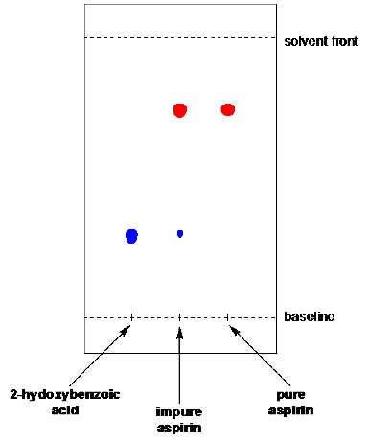

* The melting point of the impure sample is just under the normal, it is not in between as the impure sample only contains **small impurity**.
* Retention time is time from injection to detection.
* When explaining entropy changes, you can simply write more disorder (1).
* Note that you can have something clever which is both cis and optical, eg:

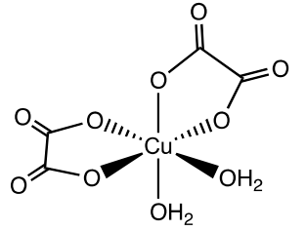

* Still have the -NH2 on ligands (eg, glycine acting as a ligand)

